VPC with subnets:

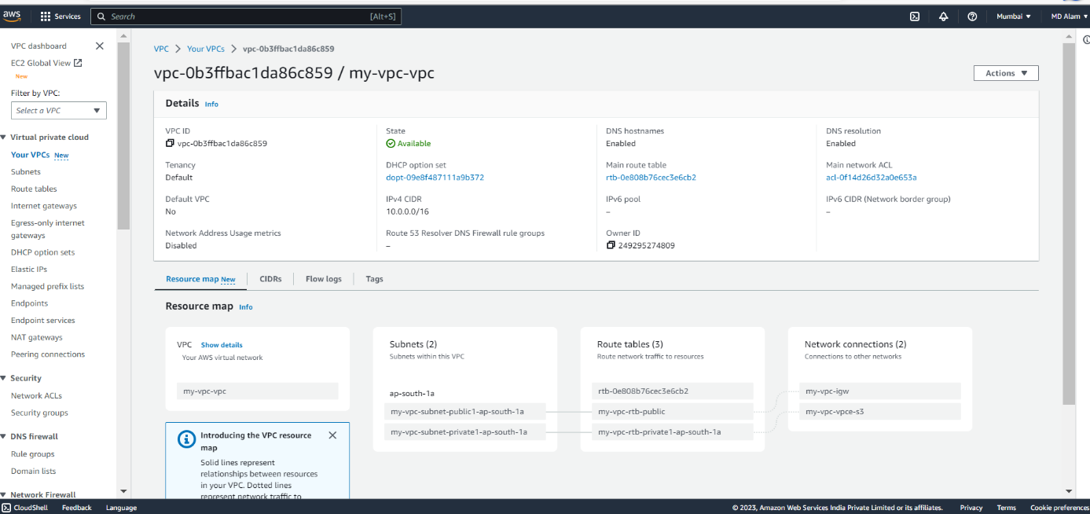

This is my VPC – “my-vpc” with its configurations.

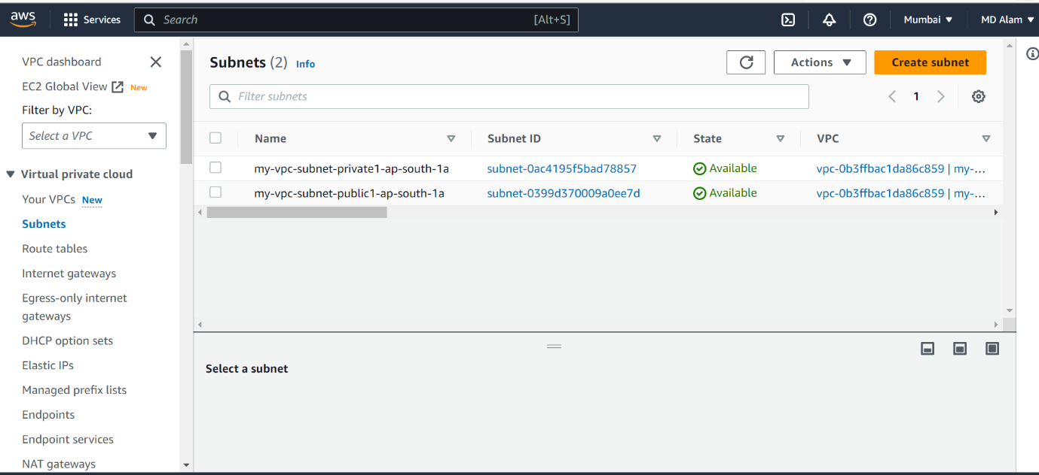

Here I have created 2 subnets. One is public and other one private with each having 16 Ips.

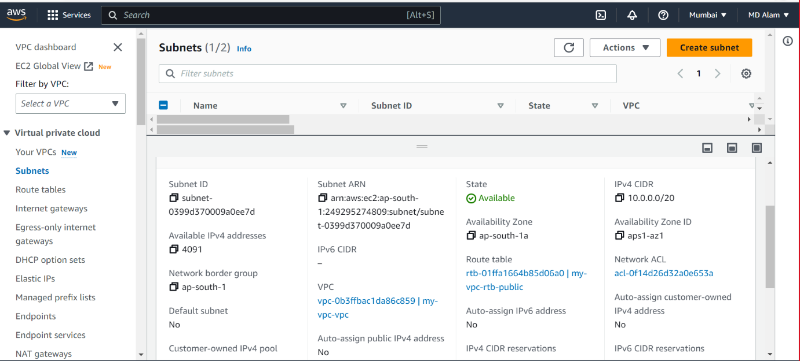

This is the configuration details of **public** subnet having Ip **10.0.0.0/20.**

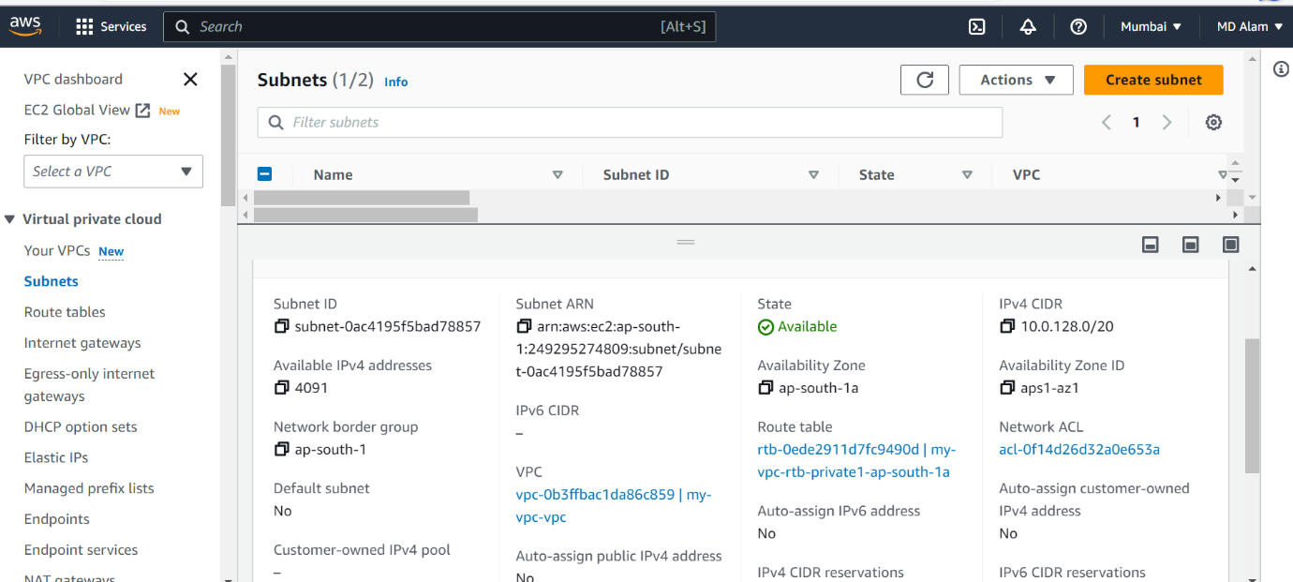

This is the configuration details of **private** subnet having Ip **10.0.128.0/20.**

Virtual Machine on public subnet

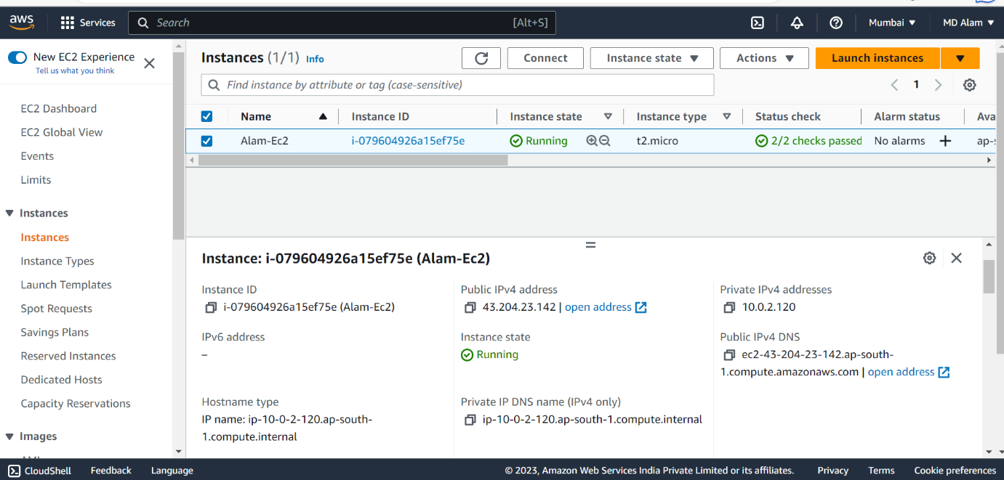

This is my EC2 having name **Alam-EC2** ready to run on windows server having public Ip as **43.204.23.142 .**

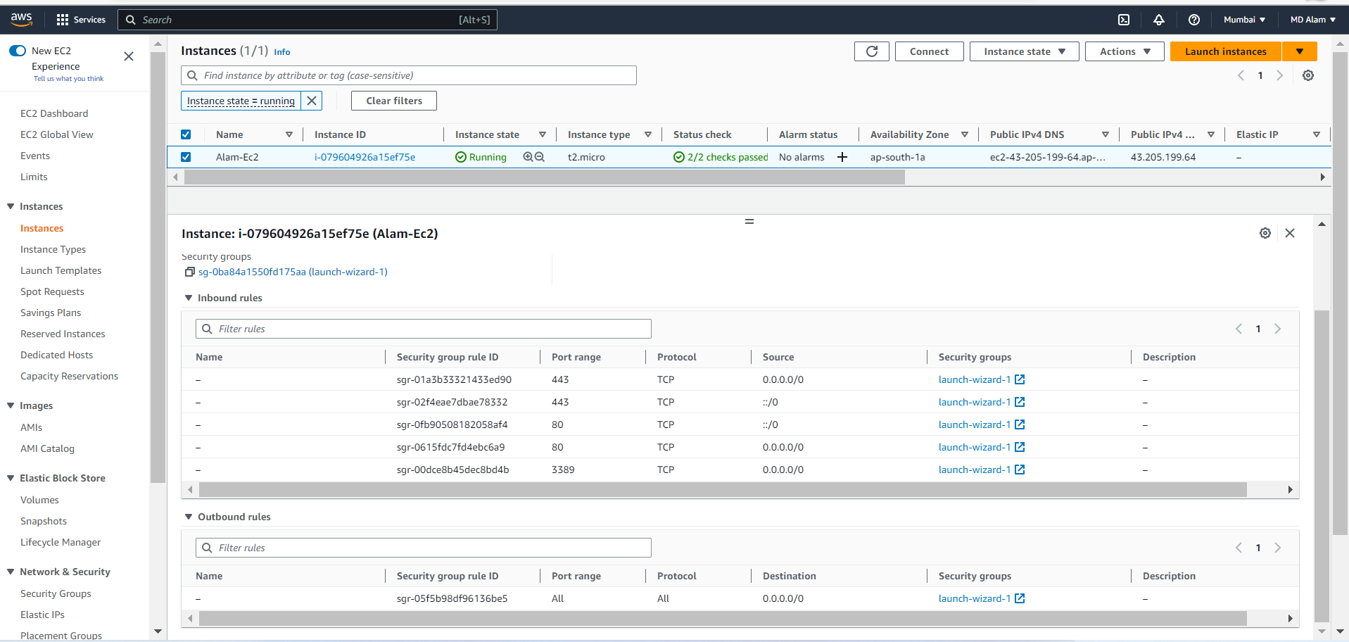

Here we can see the inbound and outbound rules of EC2.

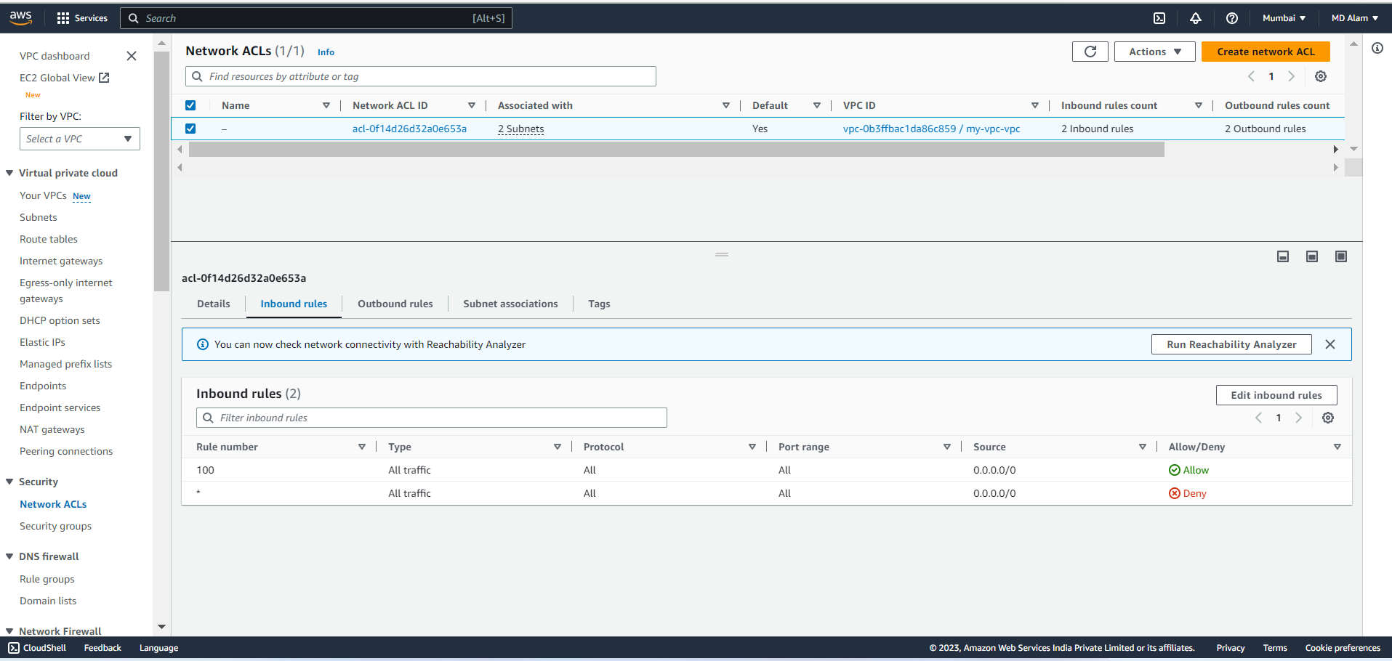

Inbound rule of NACLs

Outbound rule of NACLs

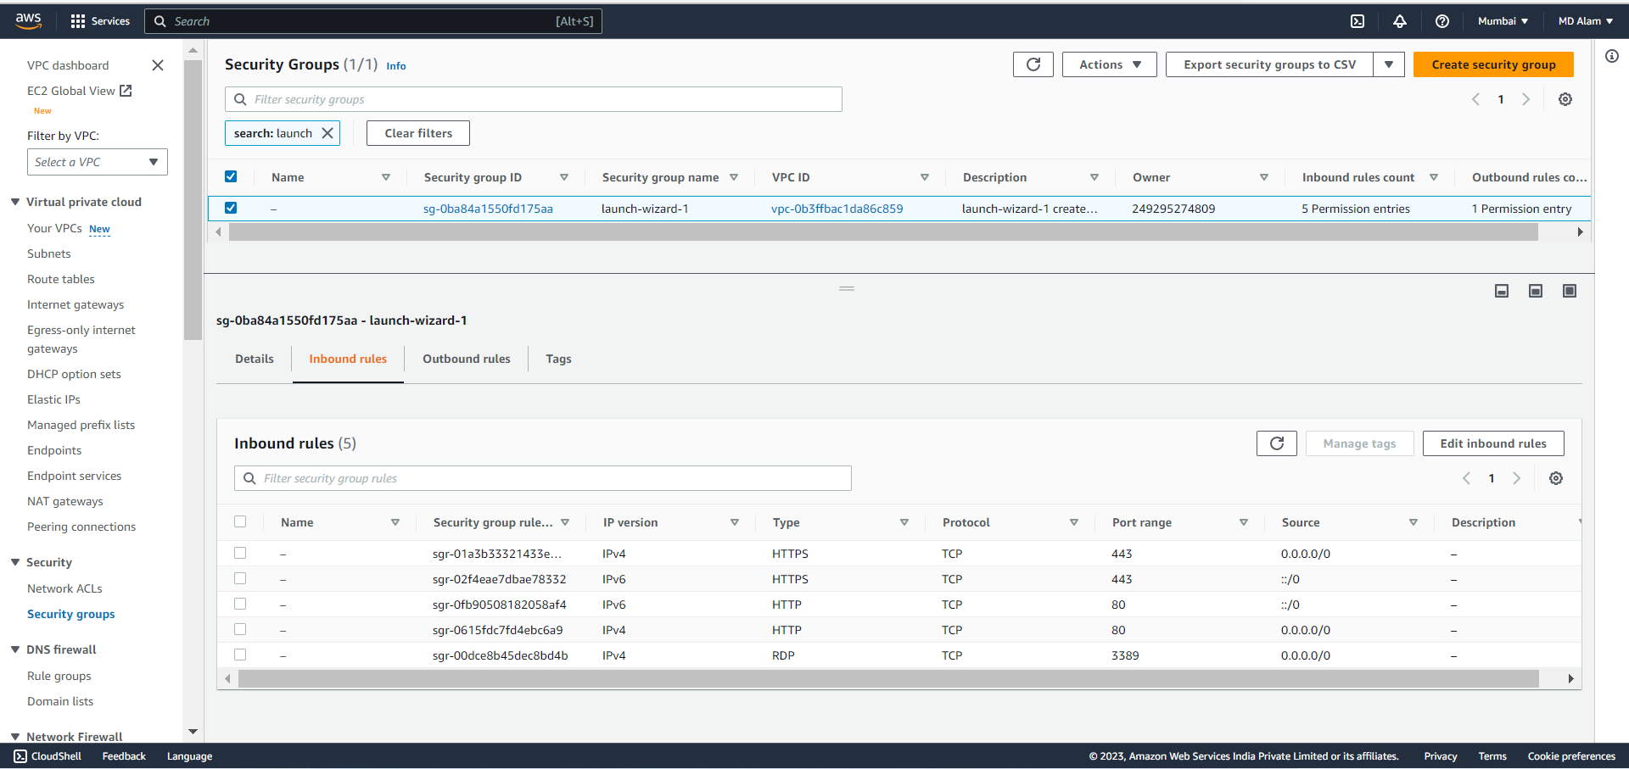

Inbound rule of SGs

Outbound rule of SGs

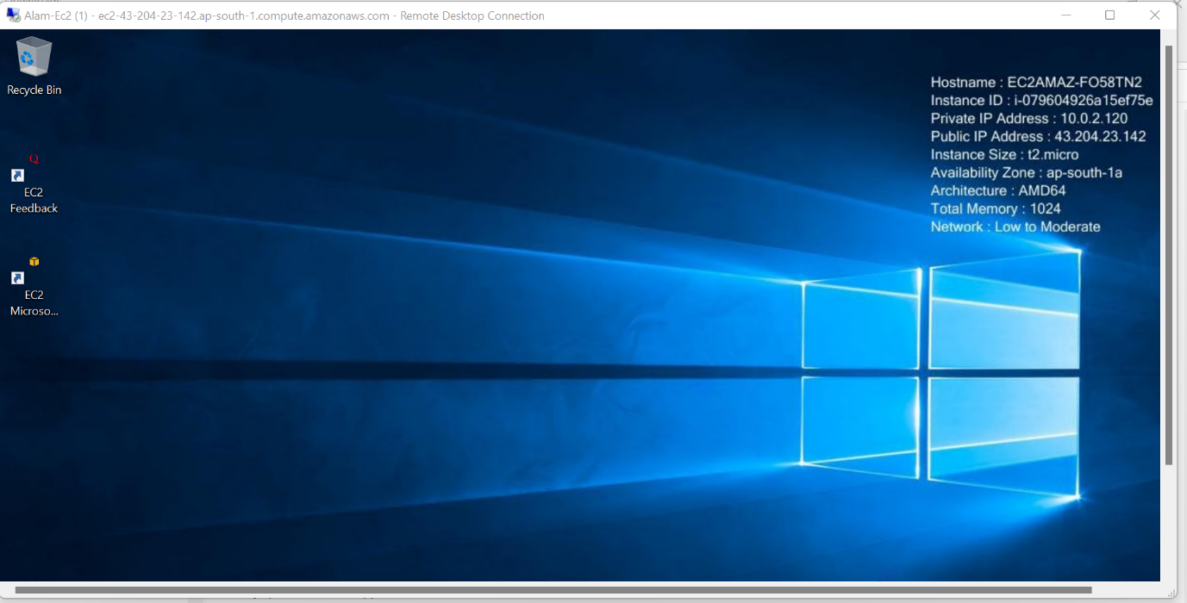

My EC2 instance running on public IP.

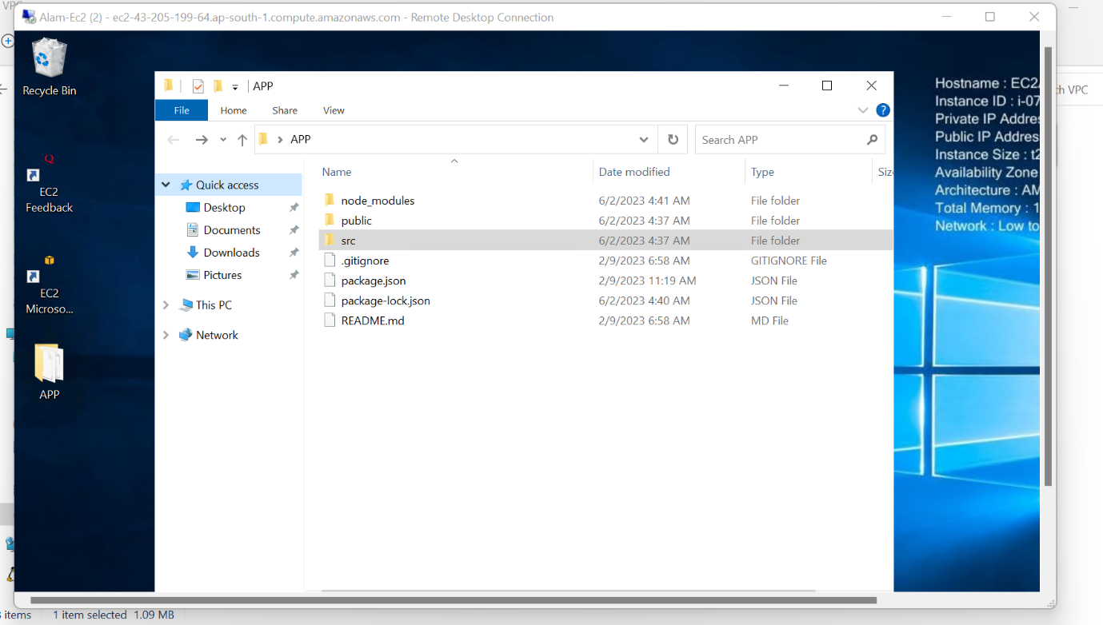

This is the application files inside APP folder inside EC2 instance.

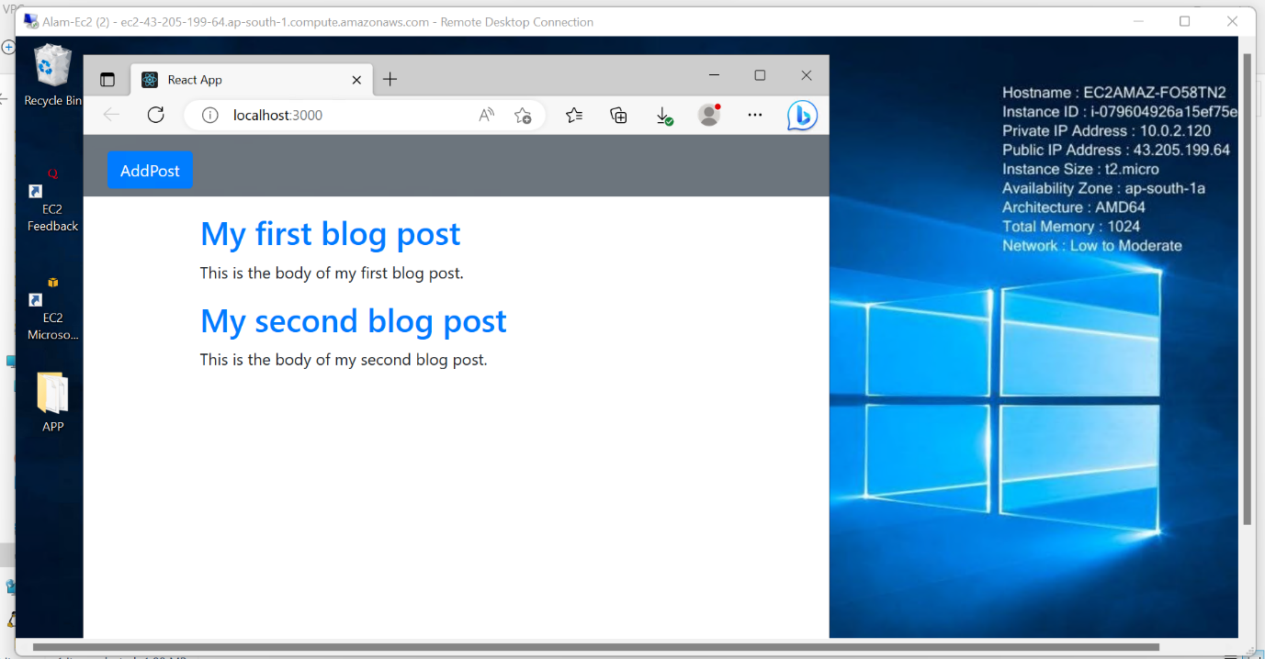

And here we can see the application running on port 3000. Its an React Application.

Lambda Function:

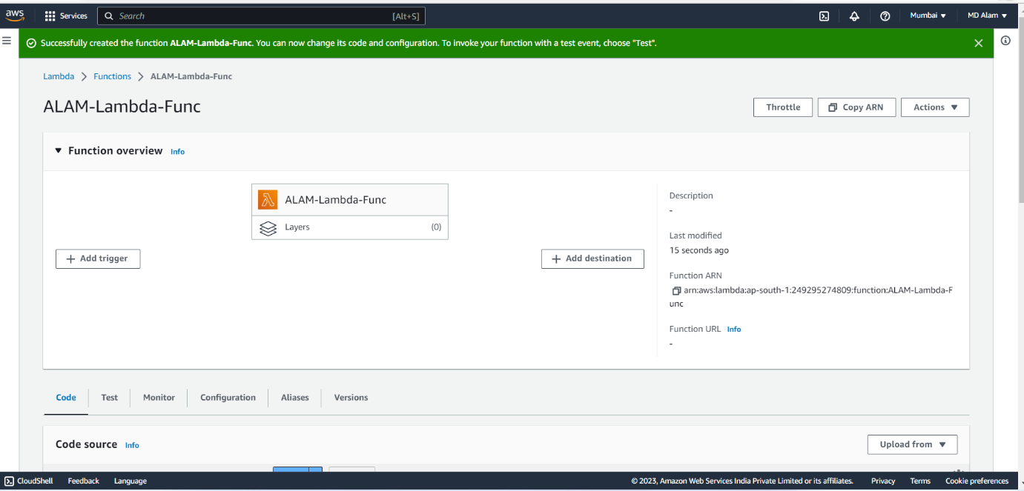

This is my Lambda function – **ALAM-lambda-Func**.

This is the S3 bucket – **alam-lambda-bucket.**

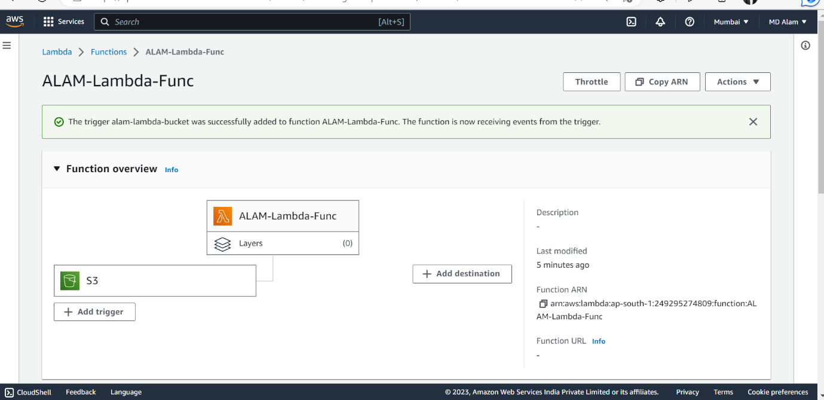

Attached the s3 bucket with the lambda function so when uploading any file into the bucket the lambda gets triggered and prints the file name.

We can see here that I have uploaded **JIRA.pptx** file inside bucket.

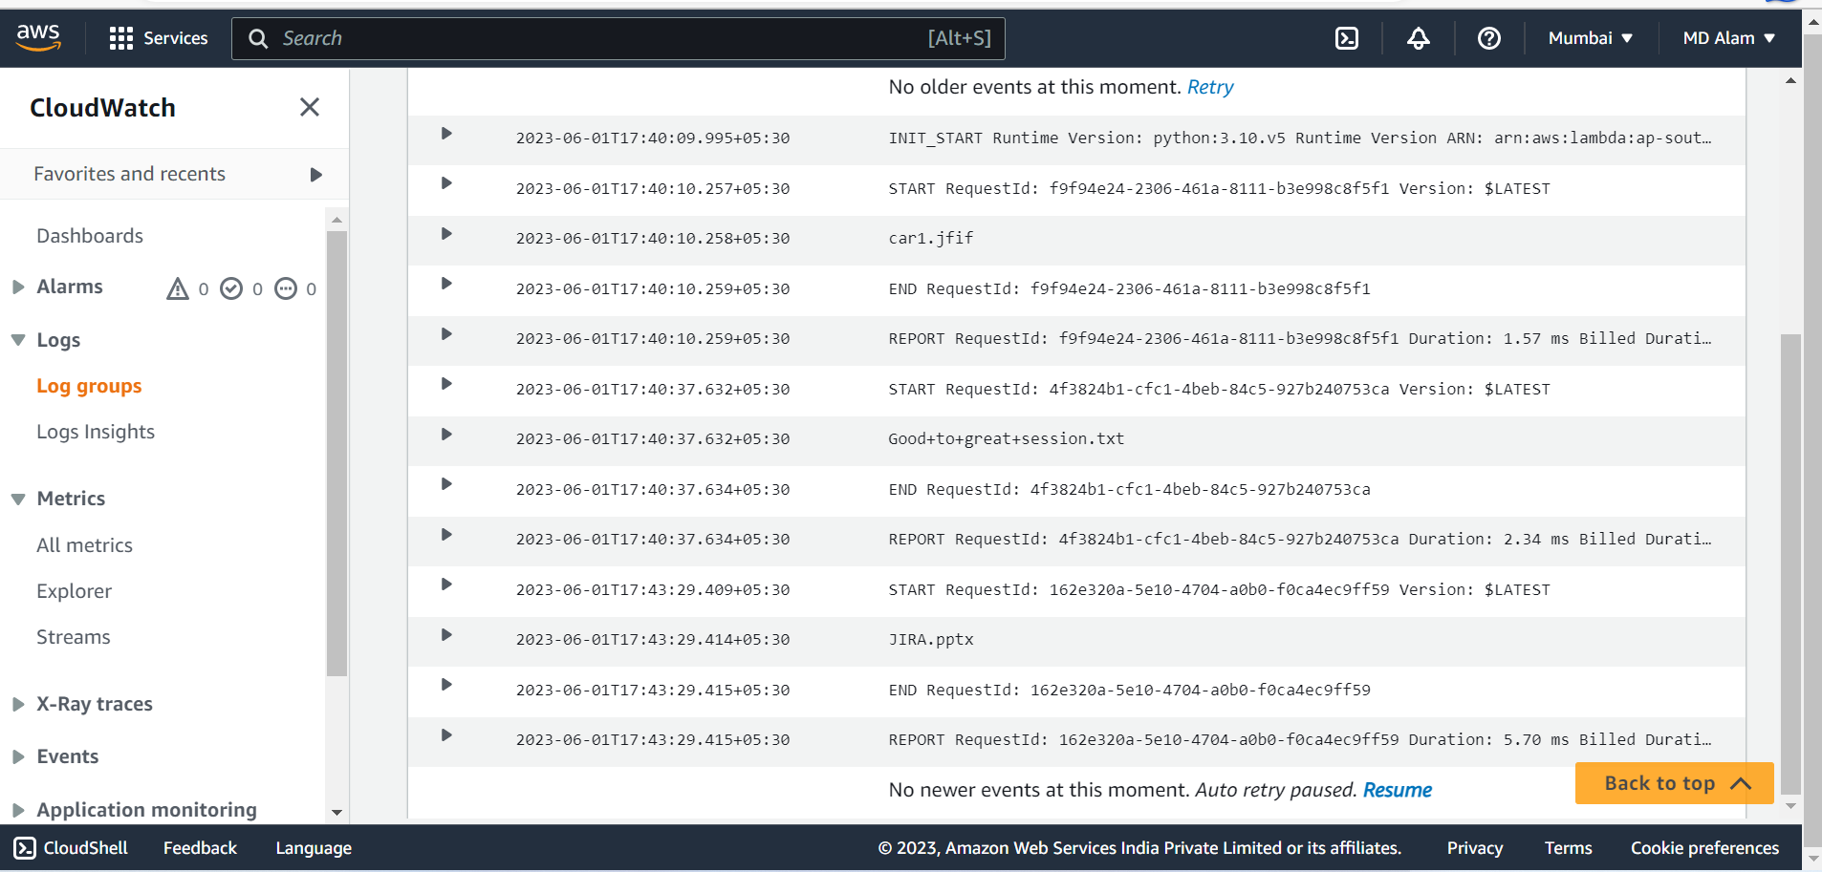



Here we can see the in the cloud watch logs the name of the file.

Lambda function code :

